Module 10

Assignment 10.3
Course: CSD402-340A Java for Programmers
Prepared By: Mirach Erkol
Date of Report: 3/8/2025

https://github.com/Mikey5007/CSD340.git

10.3 Assignment: 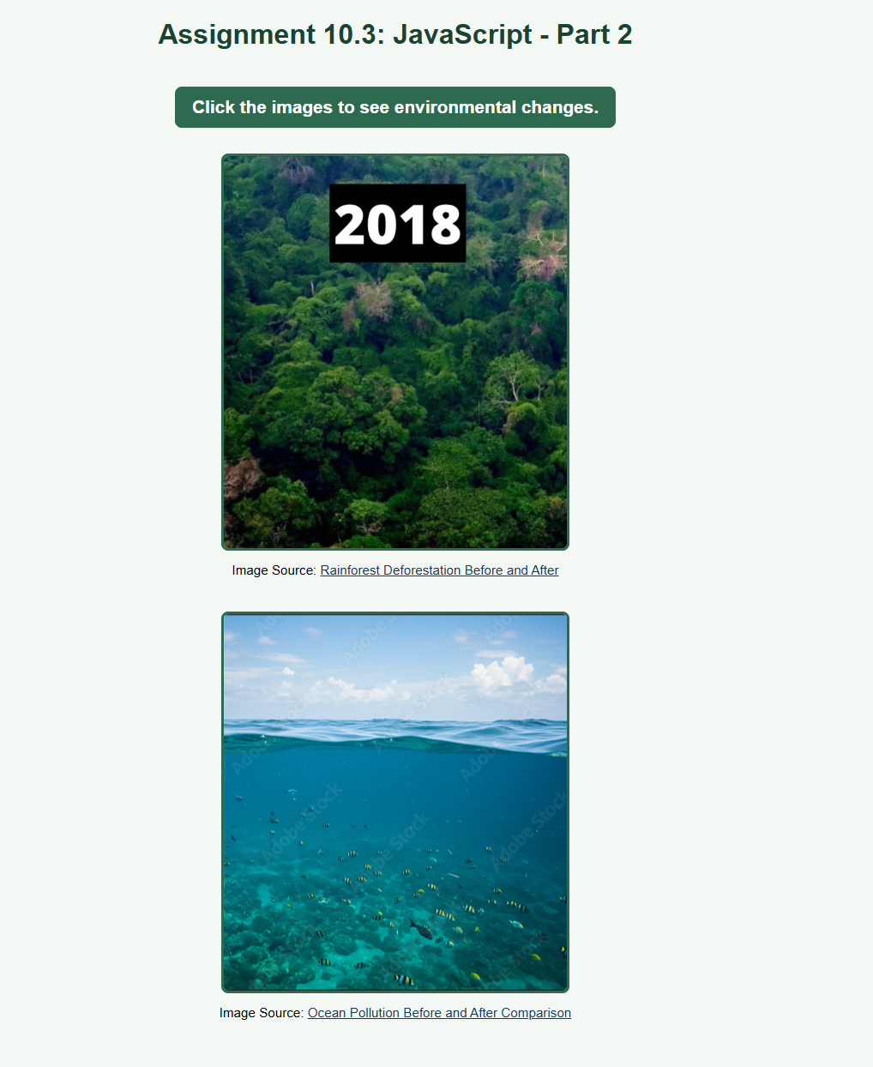

10.3 Assignment:
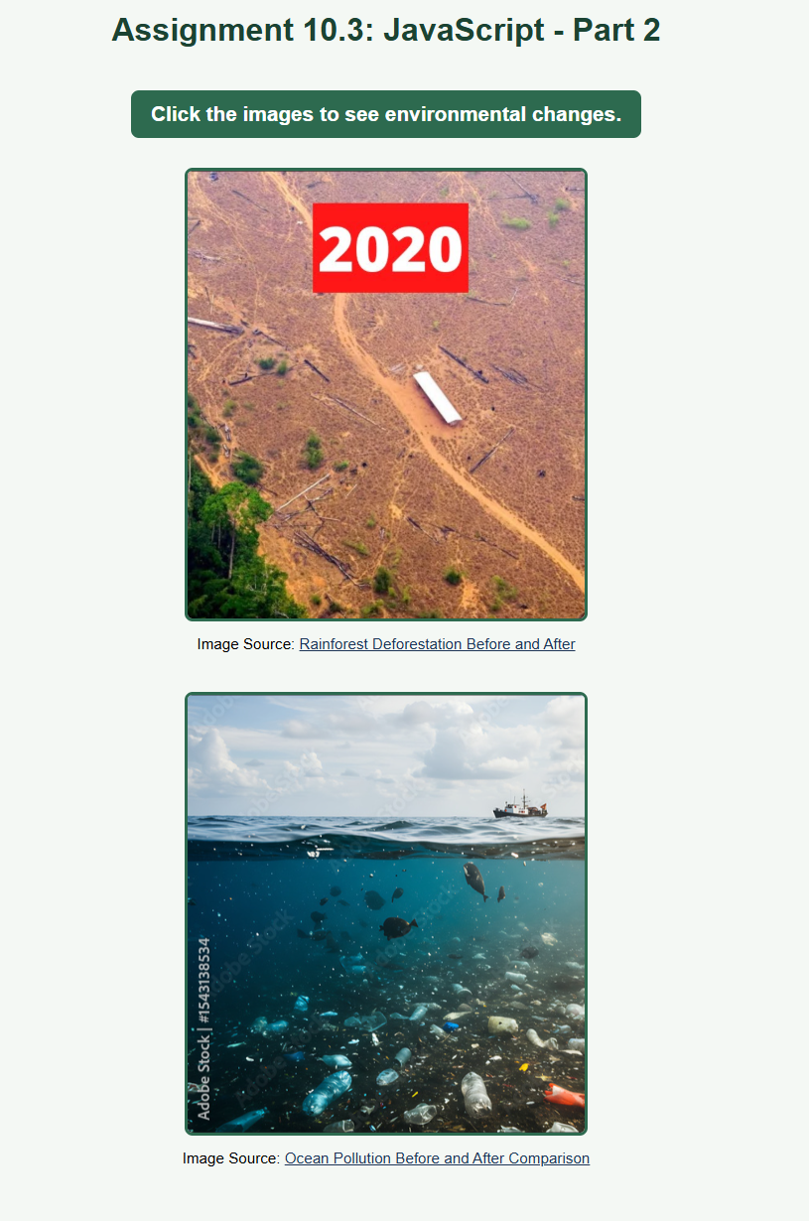

References:

https://github.com/Mikey5007/CSD340.git
https://animalia-life.club/qa/pictures/rainforest-deforestation-before-and-after
https://stock.adobe.com/ge/images/ocean-pollution-a-before-after-comparison-revealing-the-impact-of-plastic-waste-on-marine-life/1543138534

